United Way for Greater Austin -- facilitator
Meeting location – United Way for Greater Austin
October 22, 2020

Our purpose:
- Provide a learning community for early childhood stakeholders to share and discuss latest early childhood research
- Provide an opportunity for stakeholders to learn about, share and discuss community conditions
- Enable stakeholders to learn about progresses and challenges of coalition efforts and to provide feedback to in order to move the collective agenda forward
- Facilitate networking with fellow stakeholders
- Create a space for stakeholders to generate opportunities for action

3:00 | Welcome  - Meeting Norms  - Ice-Breaker
3:10-3:40 | Strategic Plan, Coalition and COVID-19 Response –  Pillar Updates Healthy Beginnings – Shalyn Bravens  - Supported Families – Shalyn Bravens  - Quality Care & Education - Anna Lisa Conlin & Cathy Doggett  - Safe & Stimulating Communities - Cathy McHorse
3:40-3:45 | Overview of ConnectATX – Jeff Cary, Amil McPeters
3:45-3:55 | Reimagining Public Safety – Listening Session information - Courtney LeBlanc
3:55-4:30 | Advocacy Work and Networking Session - Brooke Freeland
4:45 | Adjourn

https://www.unitedwayaustin.org/success-by-6-plan/

The first 2,000 days of every person’s life are foundational. Our Coalition strives to make the most of every child’s 2,000-day journey from birth to Kindergarten. The SX6 Strategic Plan is a community-wide roadmap that ensures all children in Austin/Travis County enter Kindergarten happy, healthy, and prepared to succeed in school and beyond.

The SX6 Coalition
- believes all children and families have inherent worth and an immense capacity to learn and thrive;
- values diversity and strives for equity in everything we do;
- honors the primary and vital relationship between parents/caregivers, families, and their children;
- and agrees early childhood professionals should be provided with respectable working conditions and a living wage for their important work.

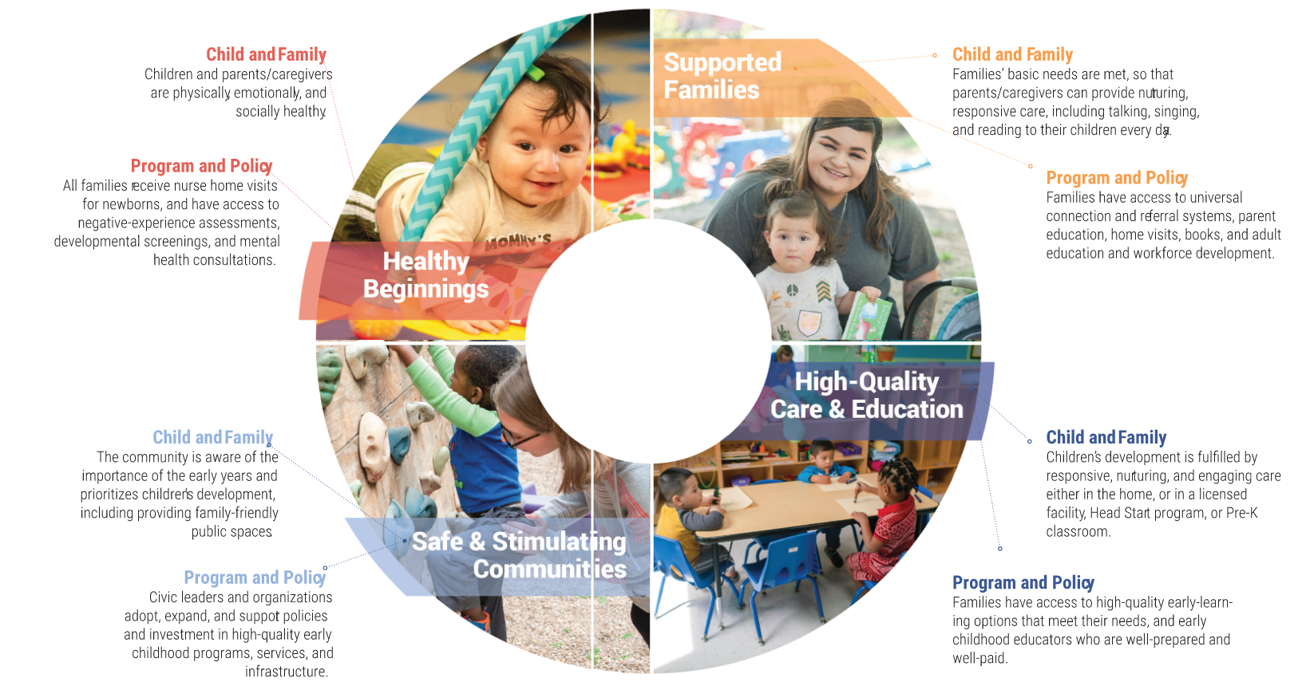
Early Childhood Framework for the Success By 6 Coaltion

