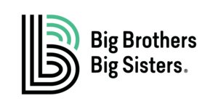
Big Brothers Big Sisters of America Announces
20201 National Mentoring Month Lids Hat Design Contest
Big Brothers Big Sisters is proud to partner with Lids to carry limited-edition custom embroidery headwear to increase awareness and help raise funds to support our mentoring programs. Customers can visit any store with a Custom Lids and choose from approved designs to be embroidered on all headwear, including blank, branded, or team caps.
We need your help to create our National Mentoring Month Design! We want you to show us why mentoring is important, by creating a design that illustrates what your friendship with your Big means to you. Your design must be a circle, but the rest of the design is up to you!
The exciting part is, a Little’s drawing could be incorporated into our National Mentoring Month hat design, available in Lids stores with a Custom Lids in January 2021. Now that’s cool!
INSTRUCTIONS
- Use the template on page 2 to design and describe your logo.
- Have the parent/guardian complete the National Big Brothers Big Sisters of America Media Release waiver to participate in this campaign, http://connect.bbbs.org/releases/ (Be sure to click on the Parent/Guardian Release Form for Minor.)
- Email or mail the design and waiver to Big Brothers Big Sister of Northern Nevada by Tuesday, November 17th.

DESCRIBE YOUR DESIGN BELOW

